Student Name: MOTEBEJANE, TP
Student Number: 43403638
Project ID: CMPG325-2026-088
Client ID: CLI-088
Assigned Organisation: Botlhale Management Consultants (Potchefstroom)
Industry: Professional Services
MILESTONE 1: CLIENT DESIGN REVIEW

CLIENT REQUIREMENTS
The client who owns the network design described by this proposal is Botlhale Management Consultants, a Potchefstroom-based professional services company, as per the authorized project allocation. The solution which is on offer still remains unique to this particular case.
Core Objectives & Design Parameters

1.Assigned Network Addressing: The assigned addressing block 172.30.60.0/23 must be used when building the network. In order to avoid waste of address space, Variable Length Subnet Masking (VLSM) must be deployed.

2.Organizational Constraint: Two different departments (Department A and Department B) which share the same floor physically must be accommodated within the new design. Of importance, however, is the fact that in order to provide privacy and isolation of broadcast traffic; these two departments must always be conceptualized as separate entities.

3. Technical Challenge: Every user access port on the edge switch must have an existing, testable solution for port security (switchport access control) put in place.

4.Client Change Request (CR4): Installing a new application/file server is needed to satisfy new operational needs. This server must be restricted such that only permitted departments can access it.

2.NETWORK TOPOLOGIES

Physical Topology Diagram
The physical topology displays the hardware connections between the end devices on the shared floor and in the server zone, the centralized access/core switch (S1-CoreSwitch), and the core router (R1-Gateway).

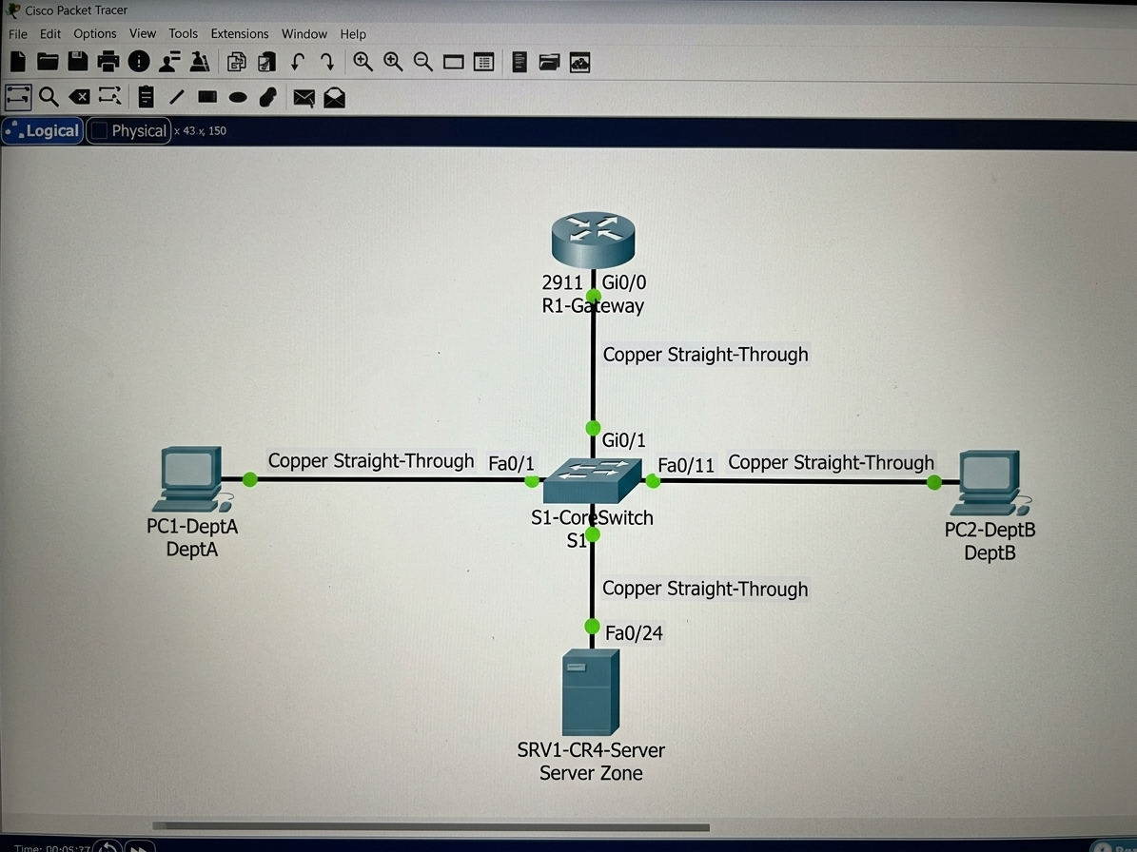

Logical Topology Diagram
Logical border segments (VLANs), inter-VLAN routing (Router-on-a-Stick), and restricted server access are all mapped by the logical topology. The separation on the shared floor is depicted in the diagrams below.

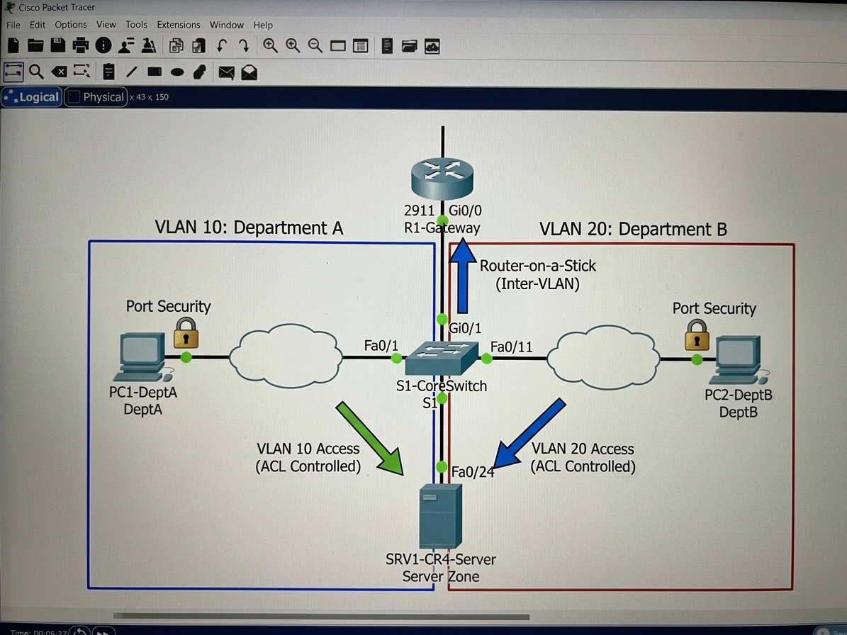

3. IP Addressing Plan
- Assigned Base Block: 172.30.60.0/23
- Subnet Mask: 255.255.254.0
- Total Usable Host IP Range: 172.30.60.1 – 172.30.61.254 (510 total hosts)

The designated block is divided into four subnets using VLSM. The architecture separates management and the new essential server infrastructure (CR4) from the common floor traffic (VLANs 10, 20).
Subnet / Purpose | Subnet Address | Subnet Mask | CIDR | Usable IP Range | Default Gateway
VLAN 10: Department A | 172.30.60.0 | 255.255.255.128 | /25 | 172.30.60- | 172.30.60.1
VLAN 20: Department B | 172.30.60.128 | 255.255.255.128 | /25 | 172.30.60.129- | 172.30.60.129
VLAN 30: Server Zone (CR4) | 172.30.61.0 | 255.255.255.192 | /26 | 172.30.61.1-  172.30.61.62 | 172.30.61.1
VLAN 99: Management | 172.30.61.64 | 255.255.255.192 | /26 | 172.30.61.65 | 172.30.61.65
Reserved / Expansion | 172.30.61.128 | 255.255.255.128 | /25 | 172.30.61.129- | N/A

